Docker Lab Exercise — Manage Docker Networks and Containers
🎯 Objective
You will learn to:
- Create Docker networks with custom subnet and gateway
- Run containers on specific networks
- Inspect and validate IPs and network configuration
- Connect/disconnect containers from networks
- Remove networks safely

🧩 Step 1: Check existing Docker networks
docker network ls
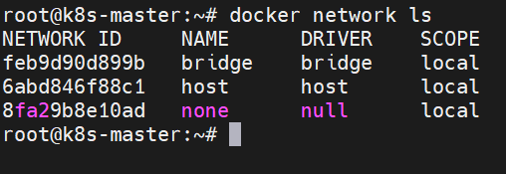
👉 Lists the default networks: bridge, host, none.

🧩 Step 2: Create the first custom network
docker network create \
--driver bridge \
--subnet 192.168.100.0/24 \
--gateway 192.168.100.1 \
net1
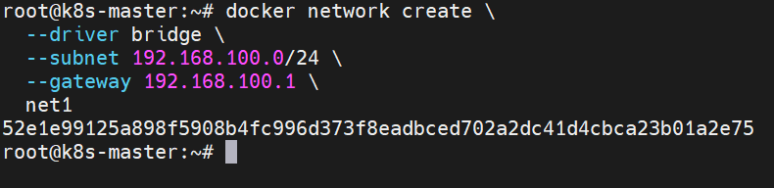
✅ Creates a network named net1 with a custom subnet and gateway.

🧩 Step 3: Inspect the network
docker network inspect net1
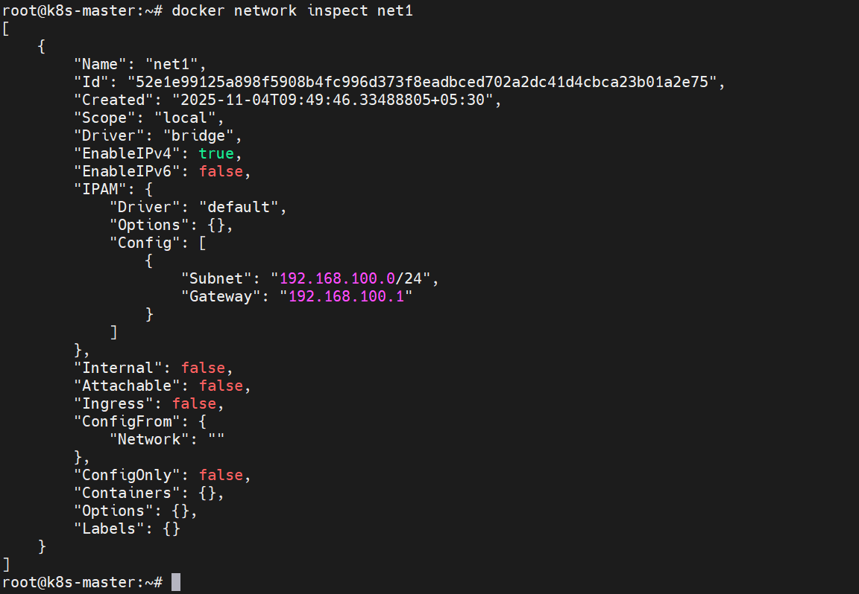
📋 Verify the subnet, gateway, and ensure no containers are attached yet.

🧩 Step 4: Run a container in the new network
docker run -d --name container1 --network net1 nginx
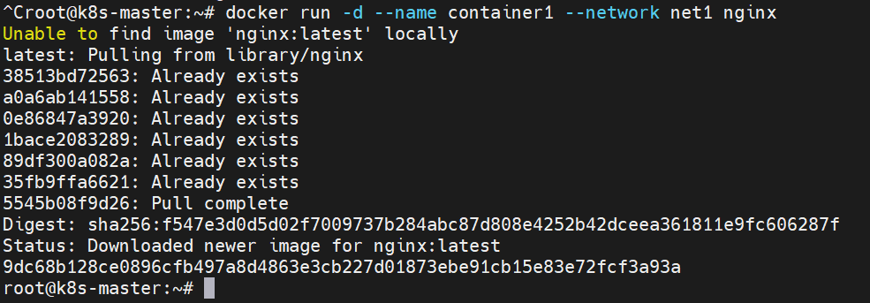
✅ Launches a container called container1 in net1.

🧩 Step 5: Validate container network and IP
docker inspect -f '{{range .NetworkSettings.Networks}}{{.IPAddress}}{{end}}' container1
or inside the container:
docker exec -it container1 ip addr show eth0
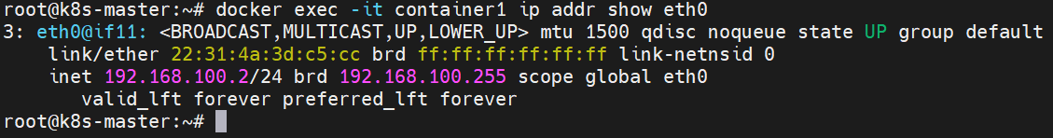
📍 Confirm that the IP belongs to 192.168.100.0/24.

🧩 Step 6: Create another custom network
docker network create \
--driver bridge \
--subnet 10.20.30.0/24 \
--gateway 10.20.30.1 \
net2
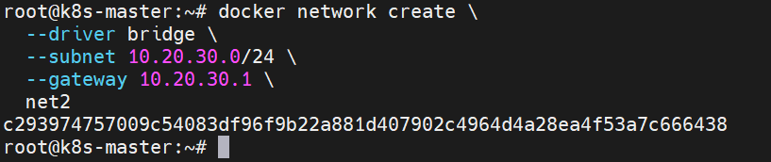
✅ Creates a second network named net2.

🧩 Step 7: Run another container in the new network
docker run -d --name container2 --network net2 nginx
✅ Creates container2 attached to net2.

🧩 Step 8: Inspect both networks
docker network inspect net1
docker network inspect net2
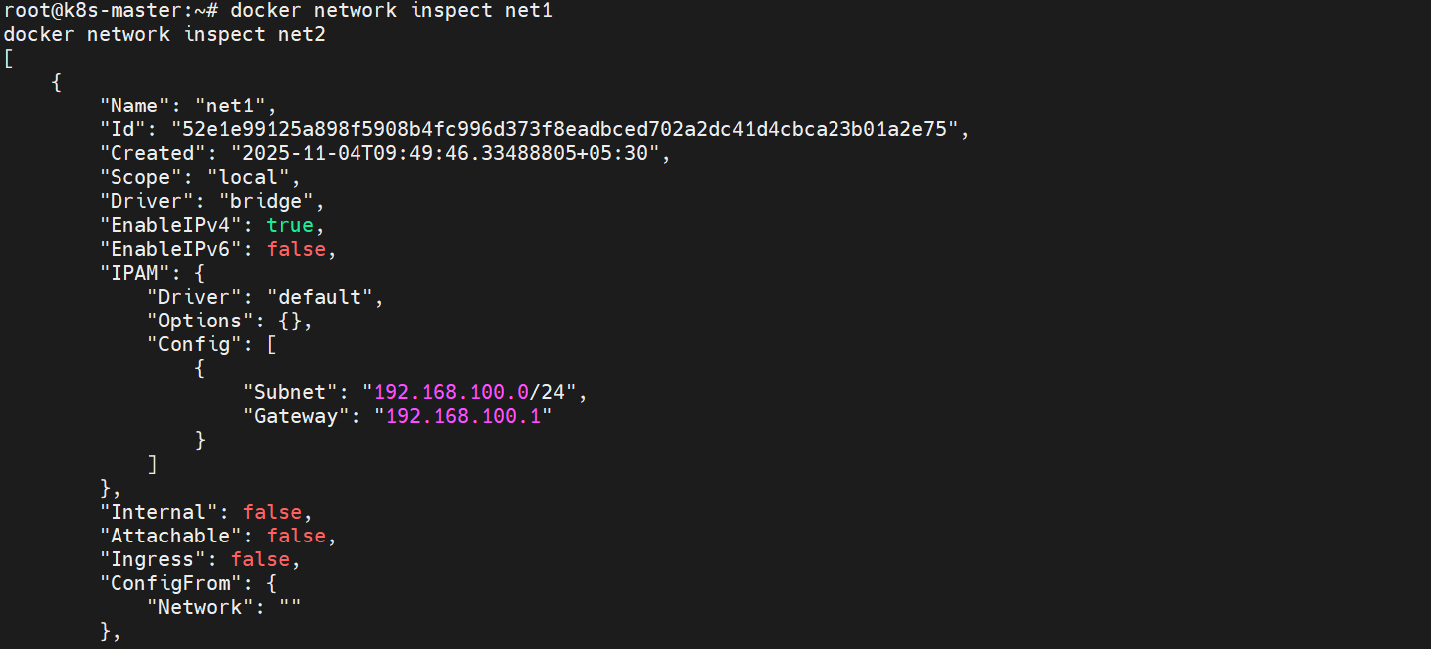
🔍 Validate which containers are connected to each network.

🧩 Step 9: Connect an existing container (container1) to the second network
docker network connect net2 container1
✅ Now container1 is attached to both networks (net1 and net2).

🧩 Step 10: Validate multi-network connection
docker inspect container1 | grep -A5 Networks
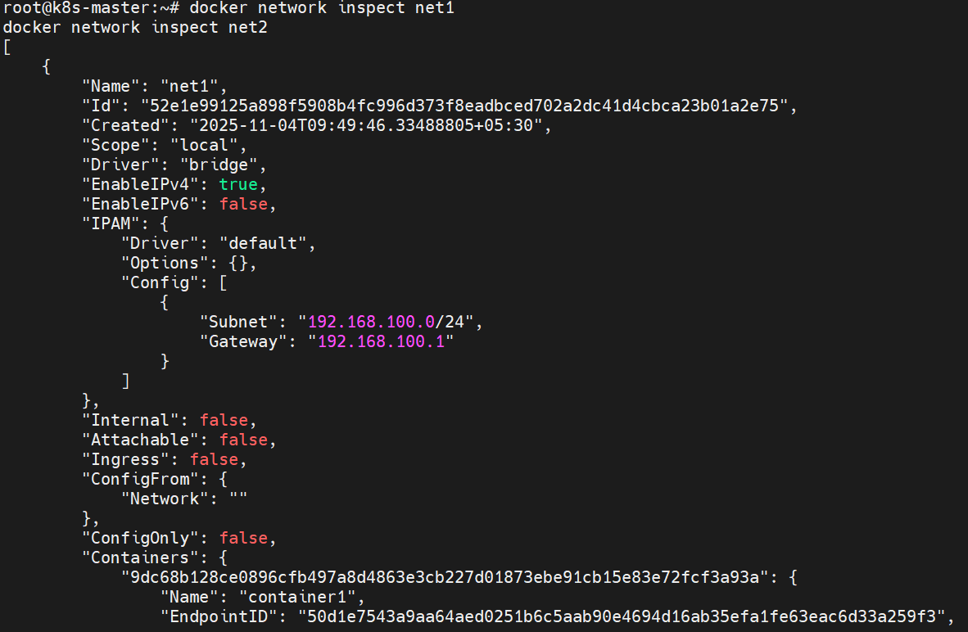
🔍 You’ll see both net1 and net2 with different IPs assigned.

🧩 Step 11: Disconnect container from one network
docker network disconnect net1 container1
✅ Removes container1 from net1.

🧩 Step 12: Validate disconnection
docker inspect container1 | grep -A5 Networks
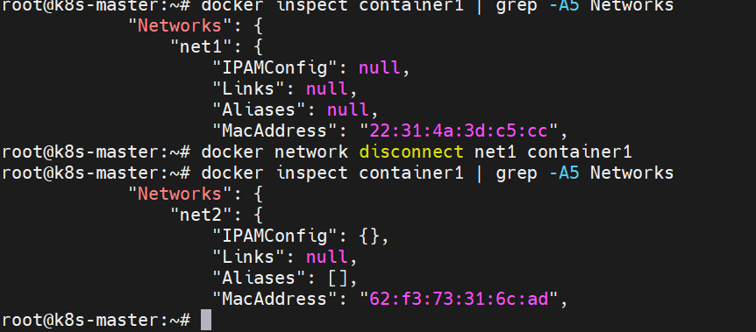
📋 Now only net2 should remain for container1.

🧩 Step 13: Remove networks
Before removing, ensure containers are disconnected:
docker network rm net1 net2
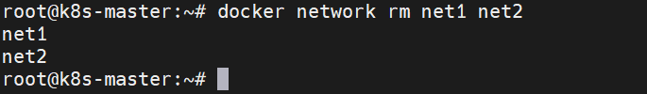
🧹 Removes both custom networks.

🧩 Step 14: Optional — Test communication between containers
To verify connectivity:
docker exec -it container2 ping -c 3 container1
💡 Ping works only if both containers share the same network.

✅ Summary of Commands
Action | Command
List networks | docker network ls
Create network | docker network create --subnet --gateway
Inspect network | docker network inspect <network>
Run container in network | docker run --network <network>
Connect container to network | docker network connect <network> <container>
Disconnect container from network | docker network disconnect <network> <container>
Remove network | docker network rm <network>

